Computer Shop System

Use-Case-Realization Specification: Edit Staff

Version 1.0

Revision History

|  |  |  |  |
| --- | --- | --- | --- |
| **Date** | **Version** | **Description** | **Author** |
| 15/12/2019 | 1.0 | details | Hoang Trung Hieu |
|  |  |  |  |
|  |  |  |  |
|  |  |  |  |

Table of Contents

1. Introduction 2

1.1 Purpose 2

1.2 Scope 2

1.3 Definitions, Acronyms, and Abbreviations 2

1.4 References 2

1.5 Overview 2

2. Flow of Events—Design 2

3. Derived Requirements 2

Use-Case-Realization Specification: Edit staff

# Introduction

## Purpose

The purpose of this use case is to describe how Edit Staff’s Profile is used and any diagram related to this use case

## Scope

This document applies to the Computer Shop Management System which will be developed by 6C17

## Definitions, Acronyms, and Abbreviations

None

## References

None

## Overview

In the following section, Use-Case Realization Specification of the Edit Staff’s Profile Use-Case of the Computer Shop Management System is provided in detail. The first section contains diagrams (sequence diagrams) describing how the use case is realized in terms of collaborating objects. The second section includes class diagrams with relationships that participate in the realization of the use case. The last section is an analysis of all requirements, such as non-functional requirements, on the use-case realization that are not considered in the design model, but that need to be taken care of during implementation.

# Flow of Events—Design

**Sequence Diagram:**

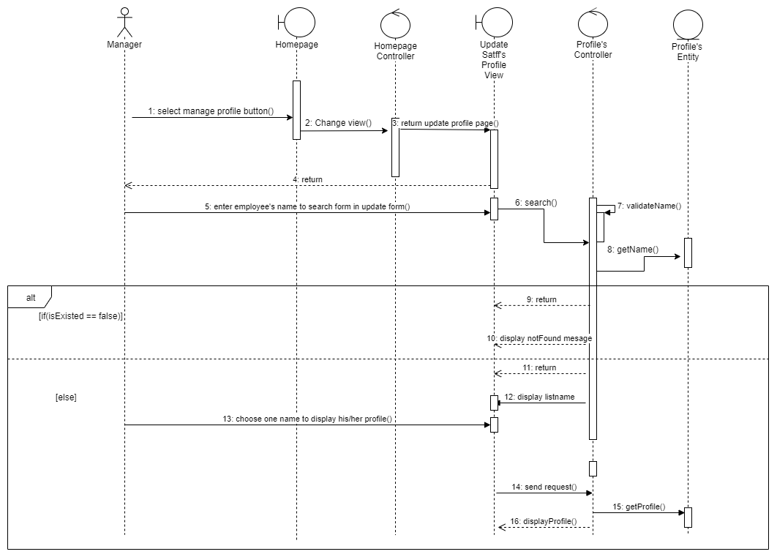

**Class Diagram**

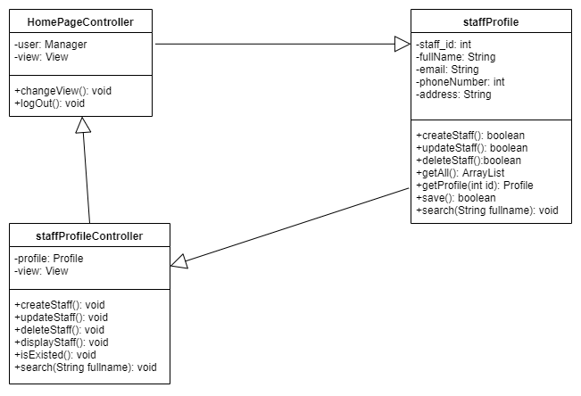

# Derived Requirements

- Email needs ‘@’

- Phone number is integer

- Password is the same as repeat password

- Some fields is not empty